***DIU CPC APP***

**Abstract:**

This system is a combination of websites and apps for desktop & android . This system is primarily designed to cpc(computer programing club) booth management system.

This is very important to takeoff programming contest. Every contestant needs to register and collect their token. CPC takeoff contest organizer needs student's registration data. So, this app can make it easier for both us, contestants and organizers.

**Introduction:**

Our DIU CSE department also has a club (CPC).CPC most popular event is takeoff programming contest. Only first and second semester students participate there. This app is for Take Off programming contest management system. Students collect their tokens by registering online. This is very helpful for cpc takeoff organizers. On a contest day takeoff organizer just need a student ID to give them a Tshirt and other contest day facilities.

**Problem Statement:**

This is an app designed by Java Swing. There we need up to 7 Jframe, where a jframe button has to connect another jframe. you just press the button and enjoy it.

TO use this app as a student first you need to login. As a new user you must be registered, after register you can easily login. Your Login information check in the database Afterall login shown CPC home page. Then they have some functionalities. You need to choose a button. There have also Takeoff online registration. After pressing takeoff registration there you can see takeoff token, and you need to fill up some information. Then you can pay in Baksh or rocket. After paying you need to download student copy takeoff token. If you need to go back to cpc home page you can press the home button.

There are also cpc organizer panels. Organizers must login their id, email or cpc-key. After login they can easily find out student token information.

These information like token, user Login, Register also saved in the database.

**UML**

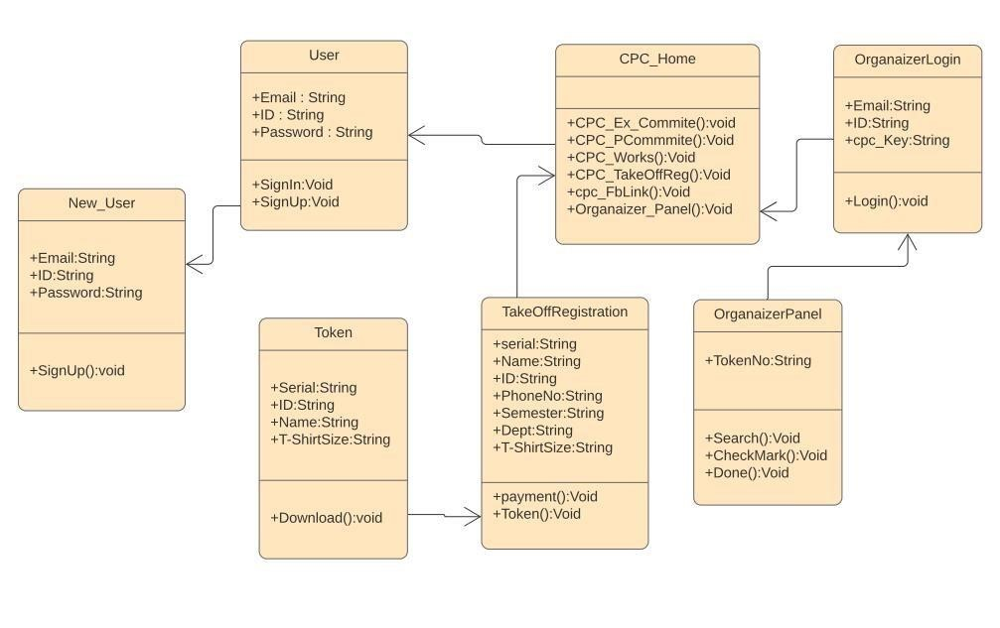

**Case Diagram:**

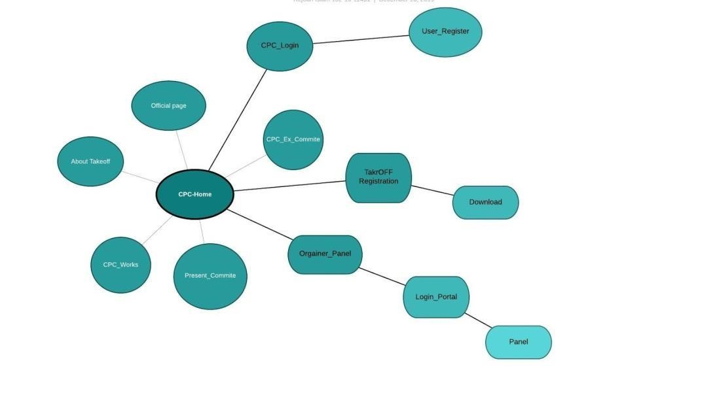

**Technologies and tools to be used:**

* **JAVA.**
* **Database (MyPHP Admin)** • **Framework - JAVA SWING.**
* **IDE: NetBeans**

**Project Description:**

**Number 1 snapshot,,** First, when you Run this app, you see a Login panel, there you need to varsity email,

ID, and your password that you put in registration. If you are a new user you need to sign up, press sign up button.

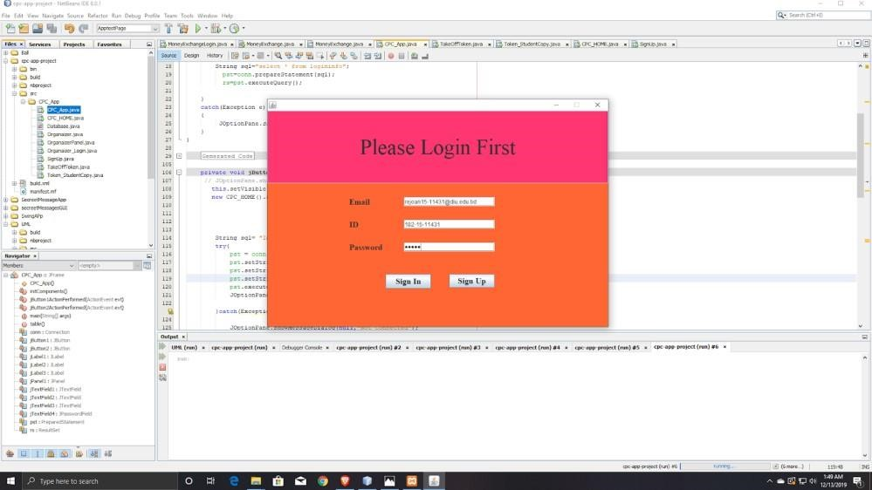

**Number 2 snapshot,,** When you press the sign-up button there is a registration page. There you need to register your university email id, varsity ID and password as you like. After press signup button there show a message dialog registration complete. If it's not done you see a message. When you sign up button that going on you login page.

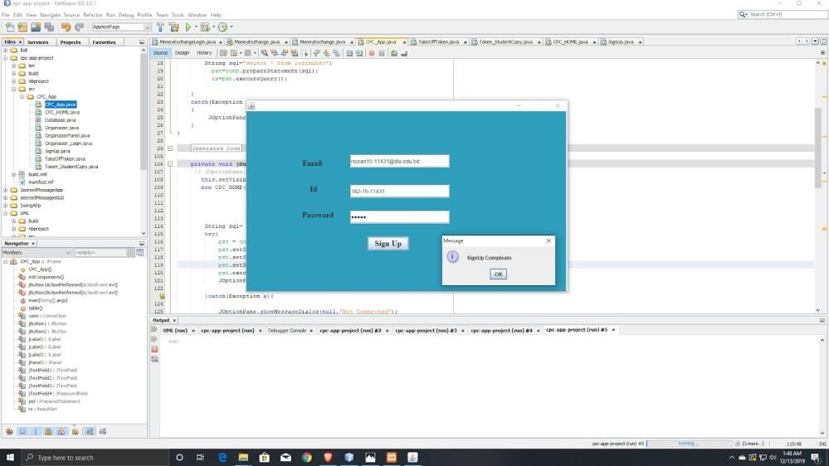

# Number 3 snapshot,

The registration data will be saved in MYPHP Admin.

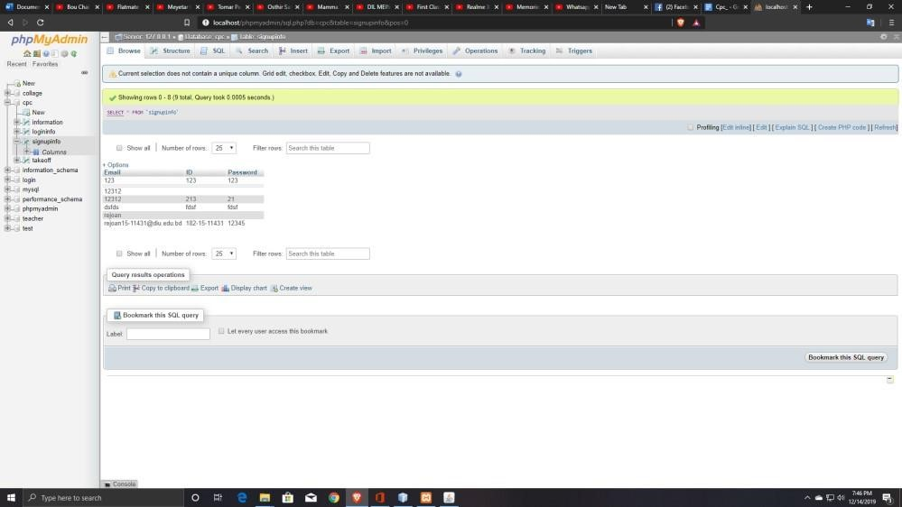

# Number 4 snapshot,,

Now you can easily login. Then a press sign in button, when you do that, this login frame will be invisible and open cpc home frame.



**Number 5 snapshot,,**Here this is cpc home. Here you can see some different button options; there you can press any button that option you want to visit. There are two important options. If you need registration, you just press it, after pressing go there you can see a cpc online registration window. Another important thing is the cpc organizer panel. If u need to open this window just press go.

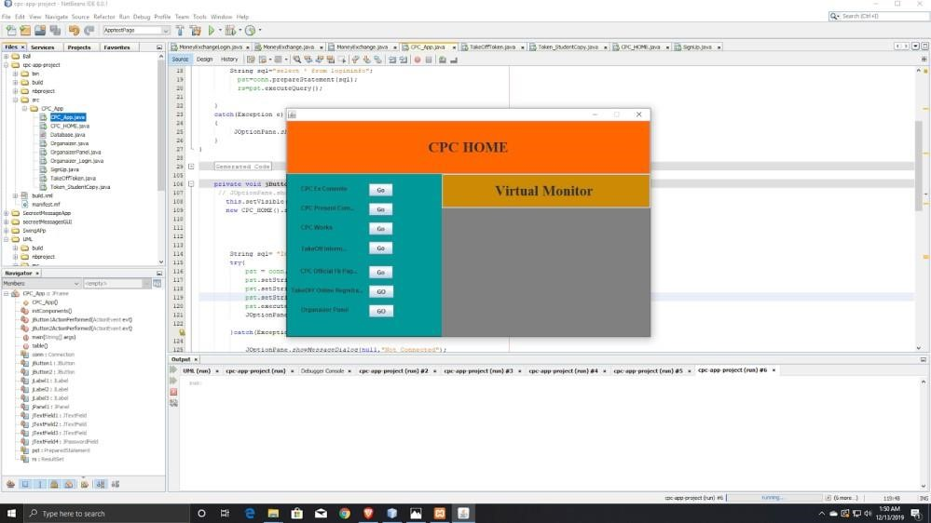

# Number 6 snapshot,,

This is cpc online registration from. Here you just put your information.

You must be in 1st semester or 2nd semester. Else you can't register. After online payment fill up you just press done.

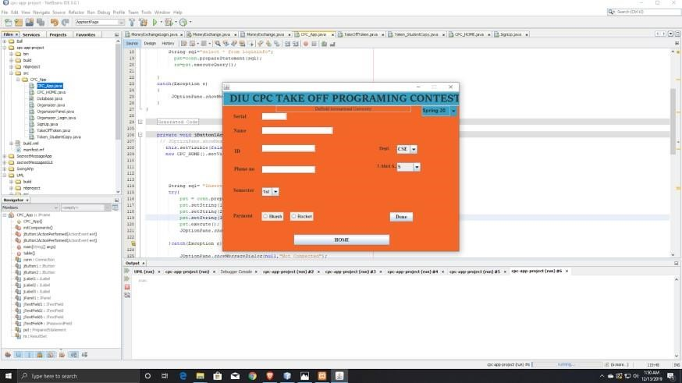

**Number 7 snapshot,,** When you press done the cpc takeoff registration window will be hide and their open Student copy of tokens, this token you can download, screenshot, whatever you like. please don’t forget to wear your DIU ID card. After collecting your token, you just easily close this app either you visit the home page for pressing home button.

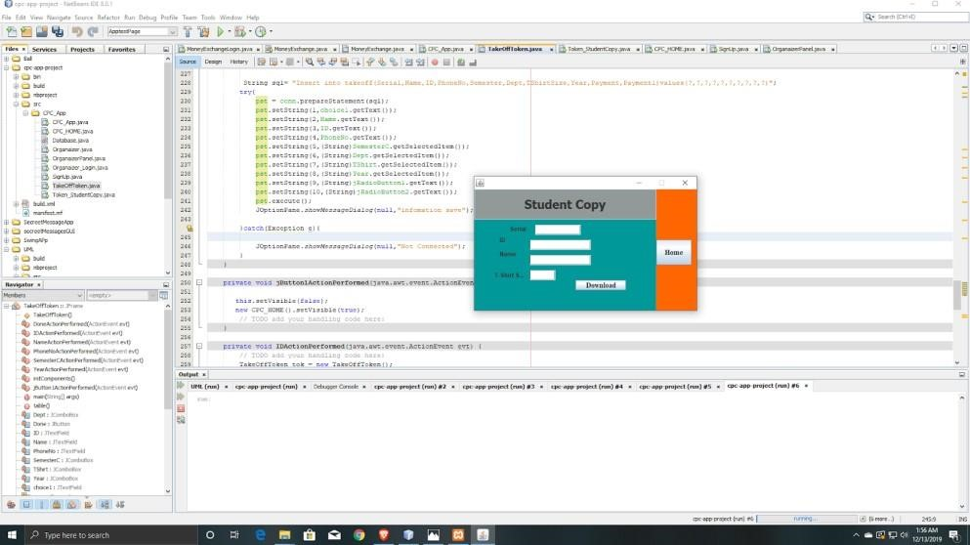

# Number 8 snapshot,,

If you are an organizer and you need to visit organizer panel, just press Go, there you have to put your email id, varsity id, cpc-key. Then you can login. After press the login button, this login window will be hide and open cpc organizer panel window.

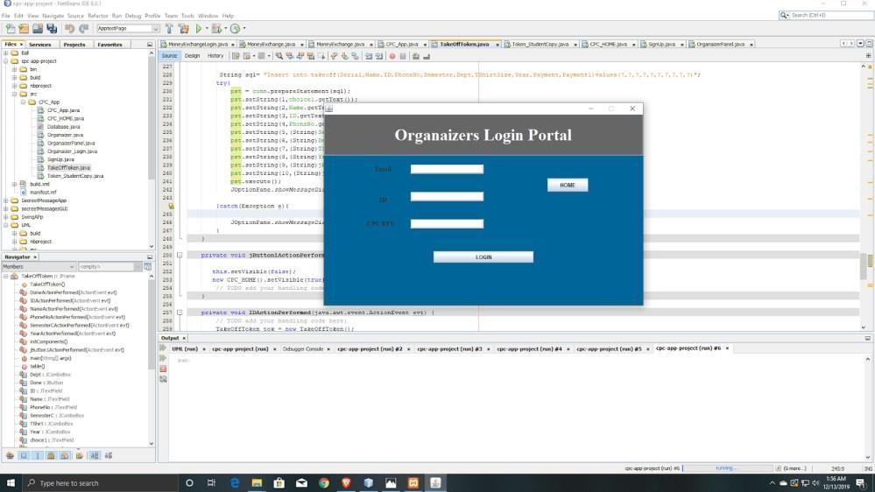

**Number 9 snapshot,,** This is cpc organizer panel. Here organizer just need student token serial no, then they can search student token. On the right side there is shown student token information. Organizer easily give them T-Shirt. When it completes you just press done button, then the organizer panel will be refreshed, you can search for another student token.

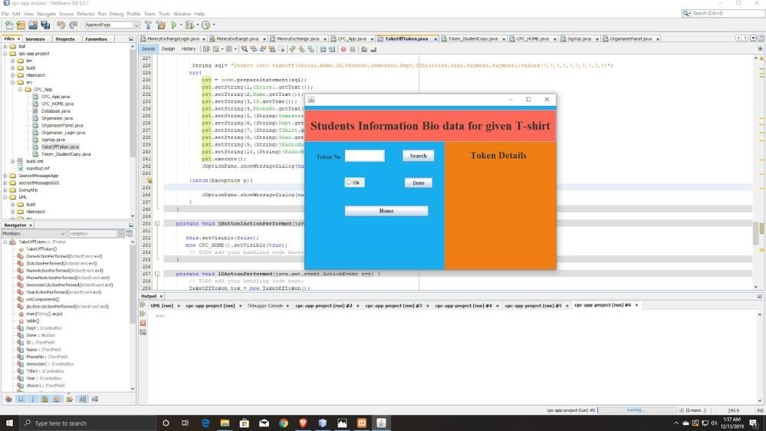

**Group Info**

**Name:** Santo Majumdar

## ID: 183-15-12012

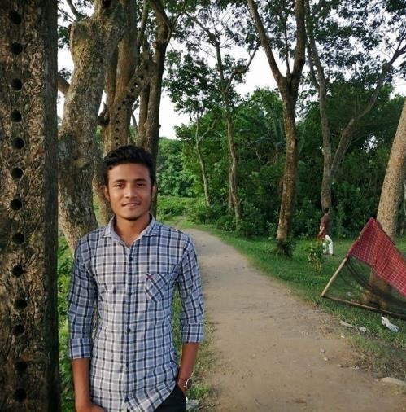

**Name**: Eshaqur Rahman

## ID: 182-15-11725



**Name**: Abul Hasnat Sovon

## ID: 181-15-10726



**Name:** Rejoan Islam

## ID: 182-15-11431



The End…..